APPENDIX K: NHOP OPERATIONAL MAPS
(TERMINAL AREAS)

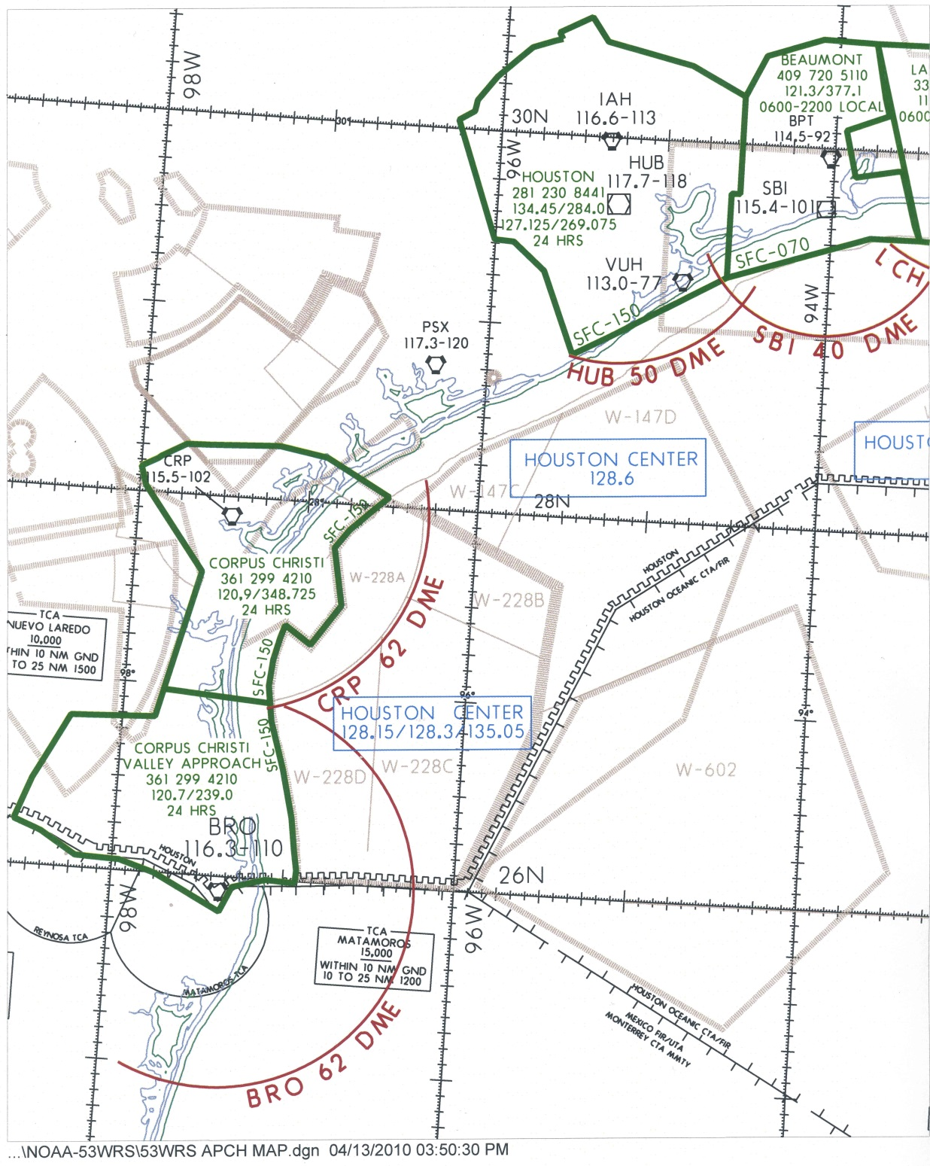
Figure K-1. Texas Coast

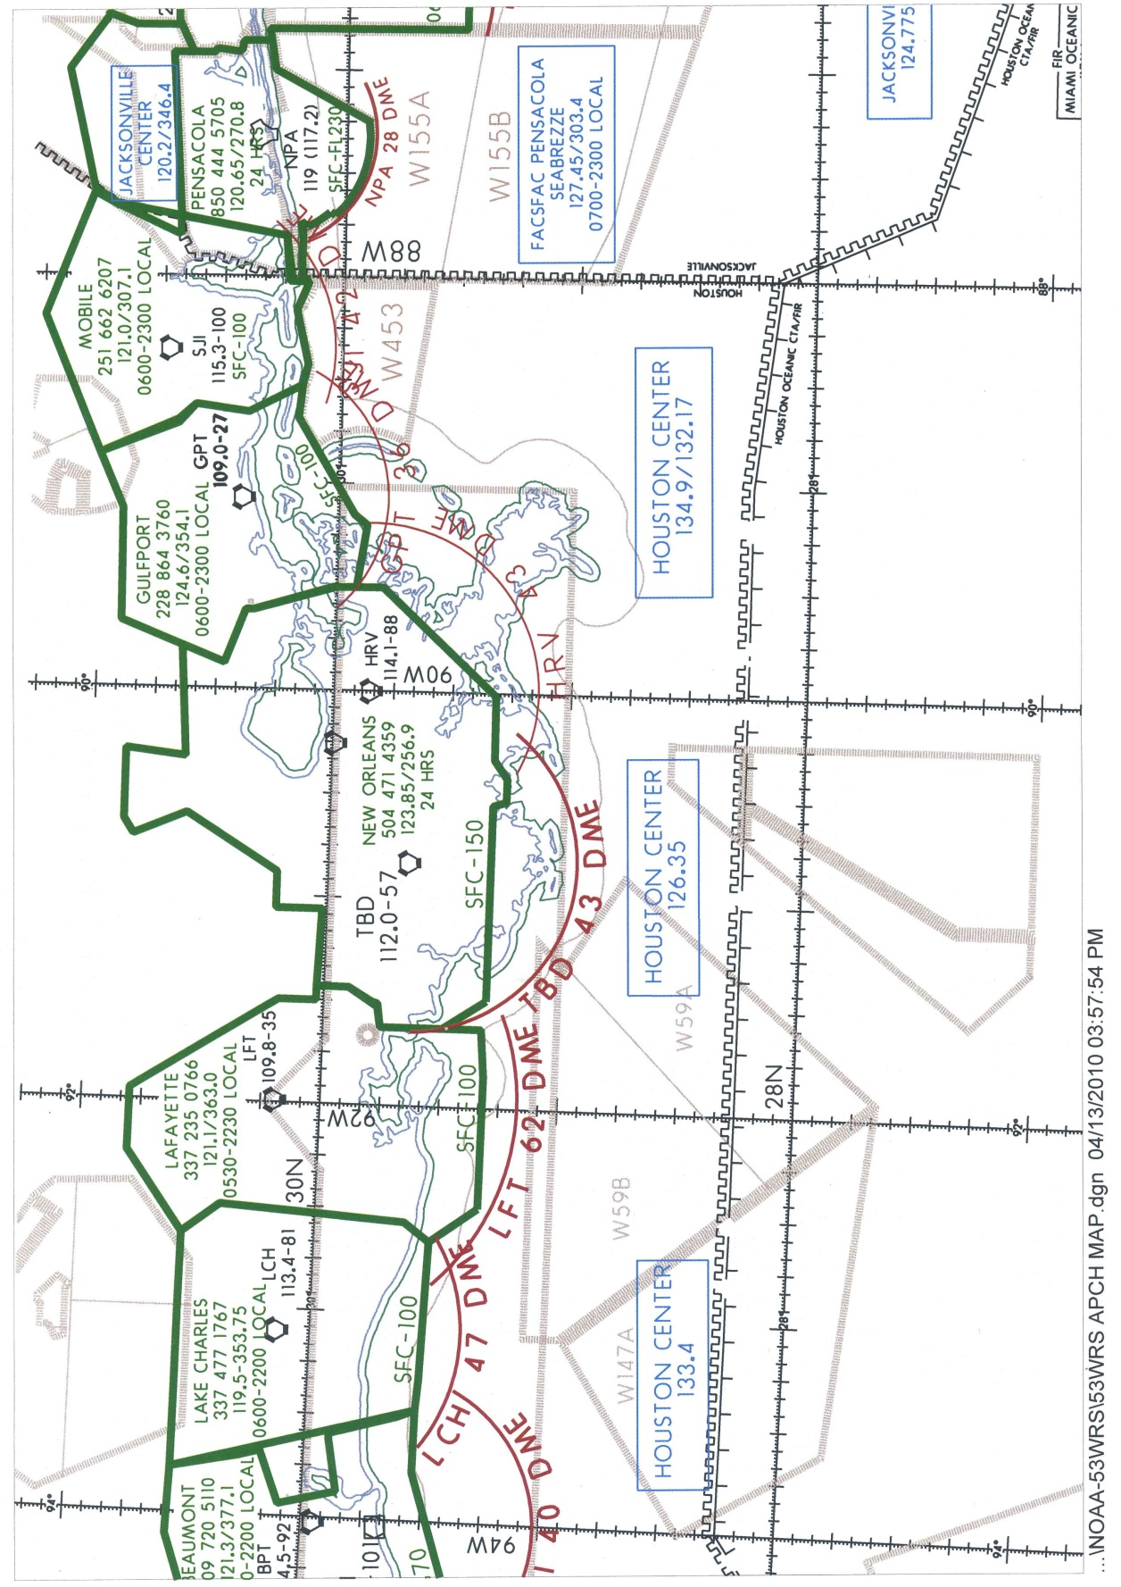
Figure K-2. Lake Charles, LA - Pensacola, FL

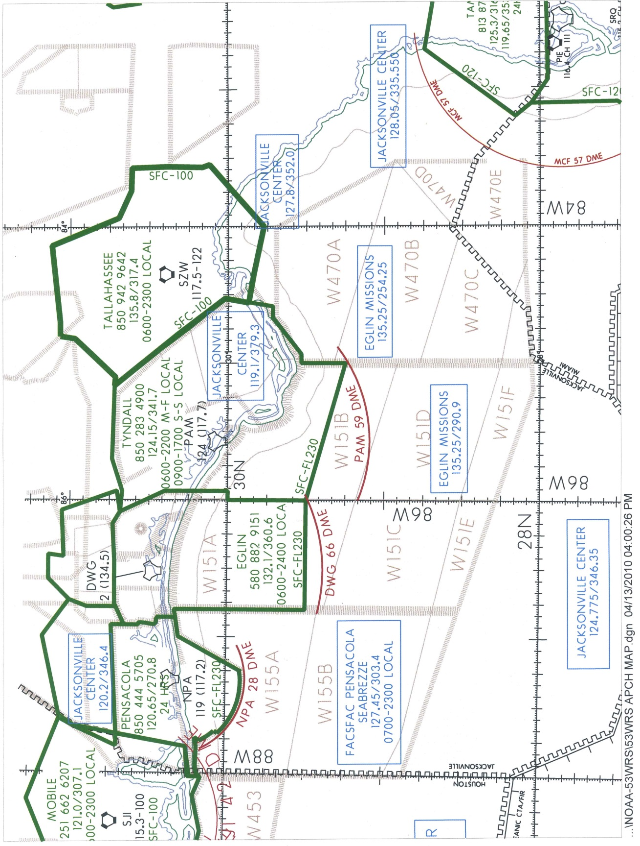

Figure K-3. Pensacola, FL – Tallahassee, FL
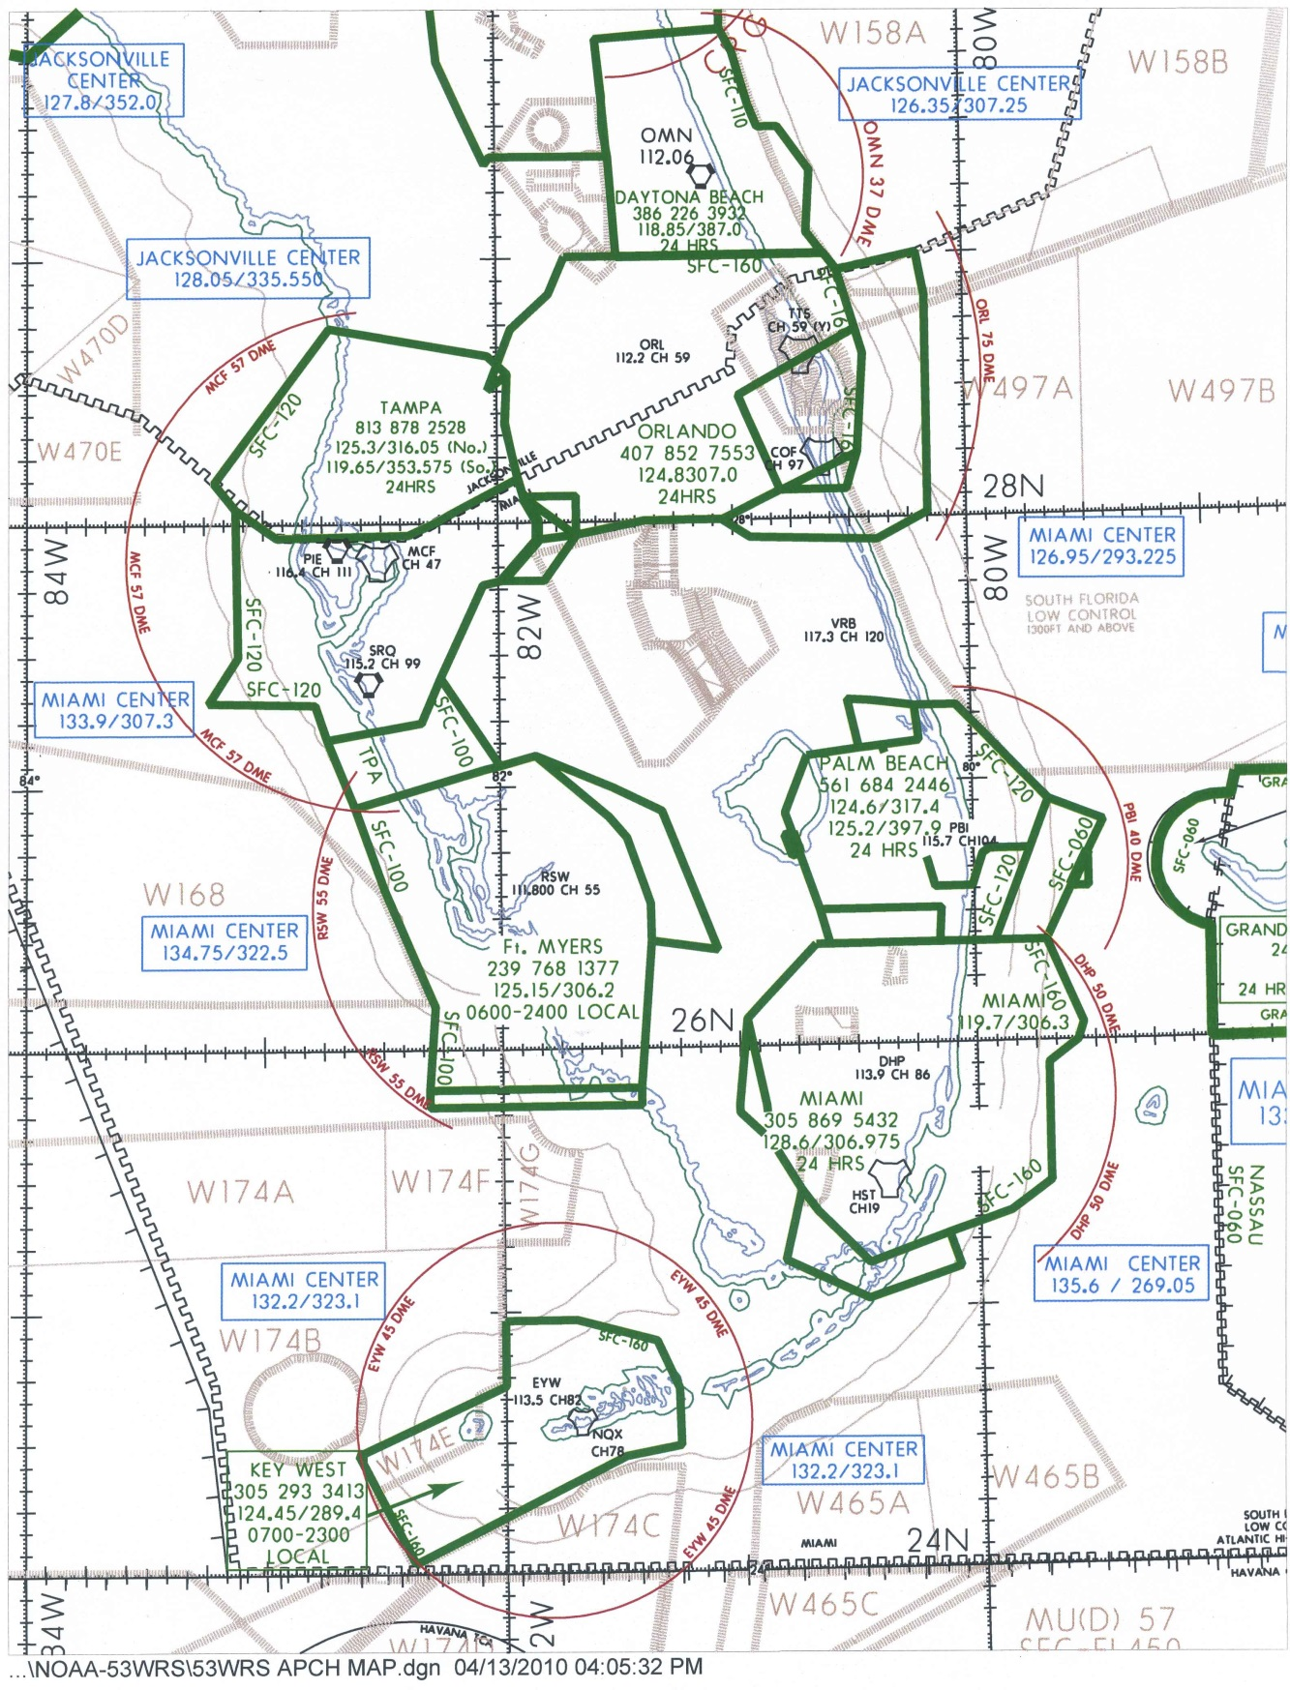

Figure K-4. Central/Southern Florida
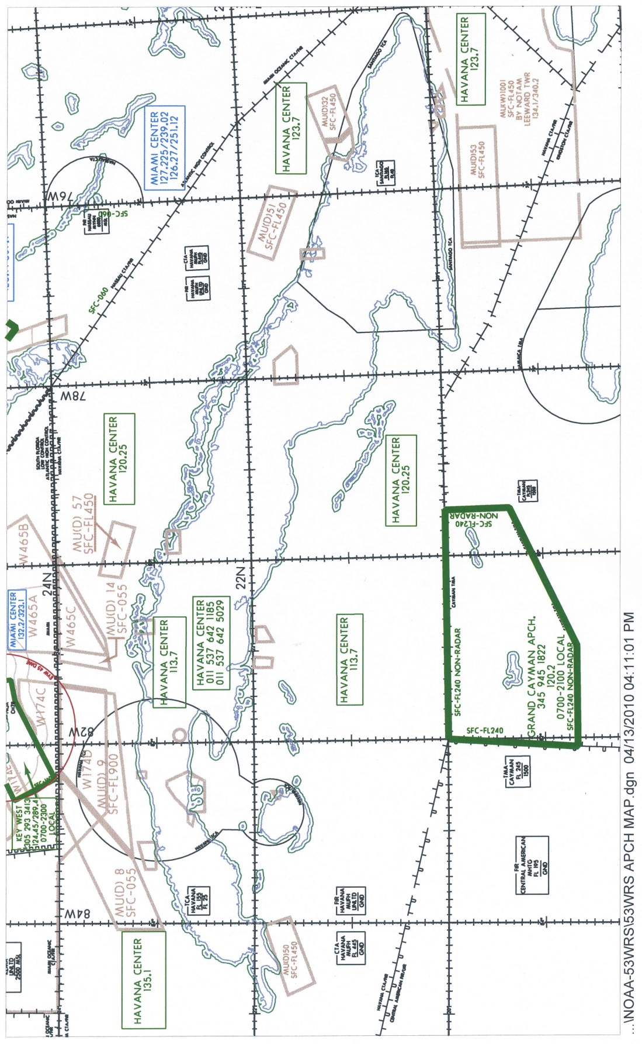

Figure K-5. Cuba – Grand Cayman
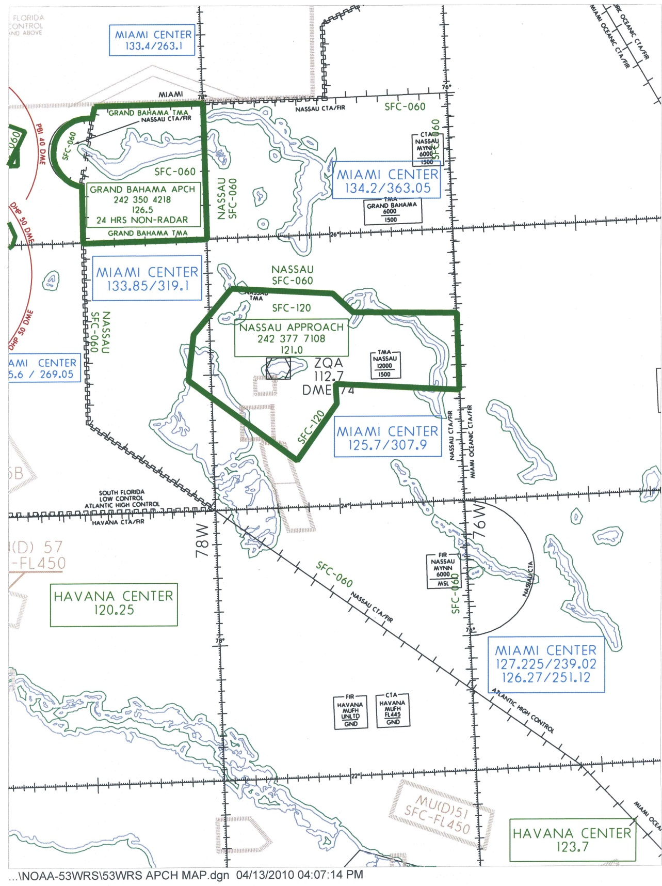

Figure K-6. The Bahamas: Nassau - Freeport

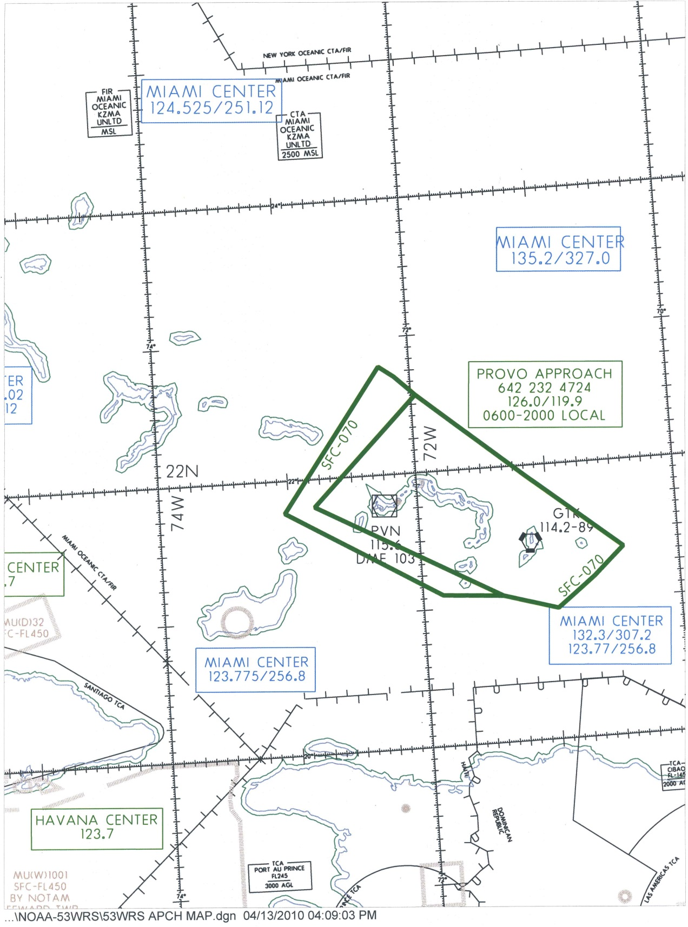
Figure K-7. Turks & Caicos Islands: Grand Turk - Providenciales
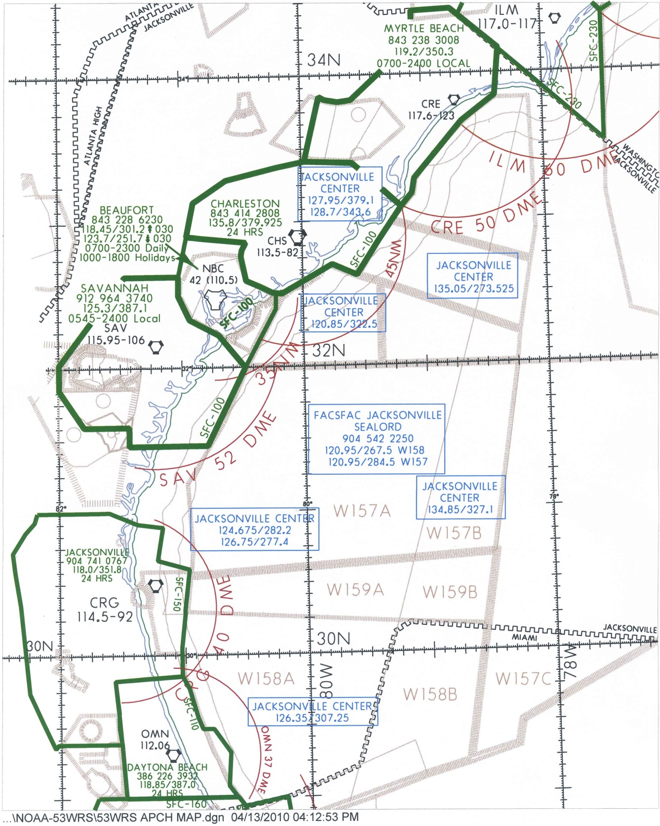

Figure K-8. Daytona Beach, FL – Myrtle Beach, SC
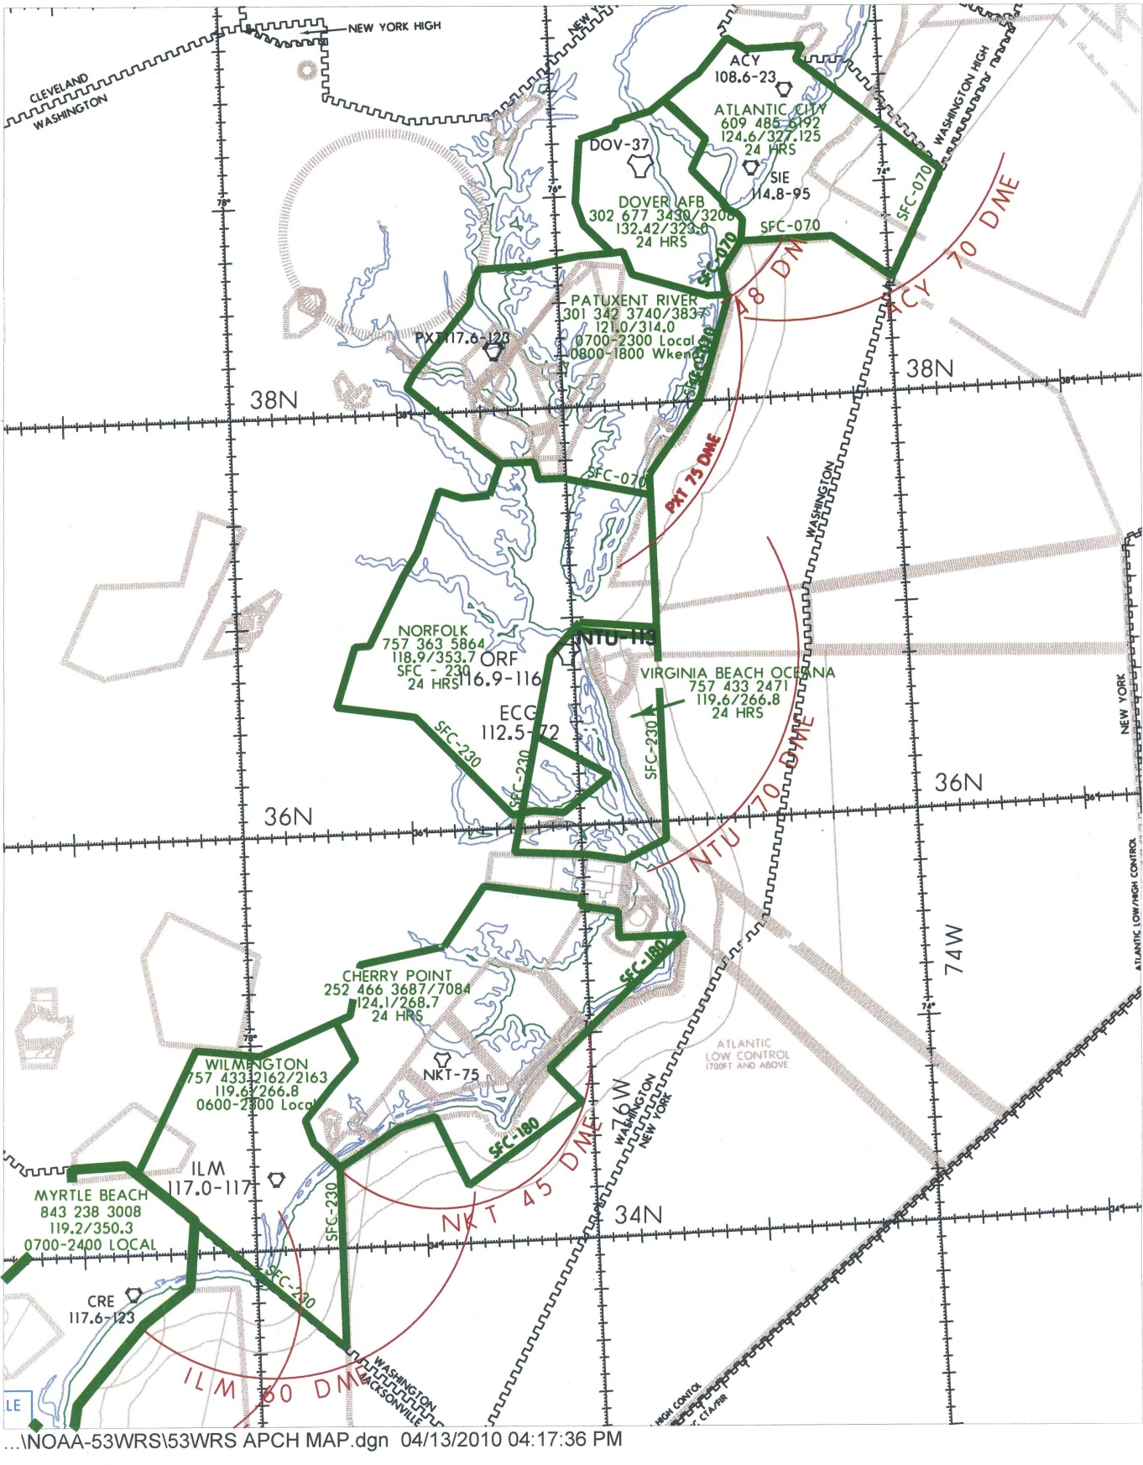

Figure K-9. Wilmington, DE – Atlantic City, NJ
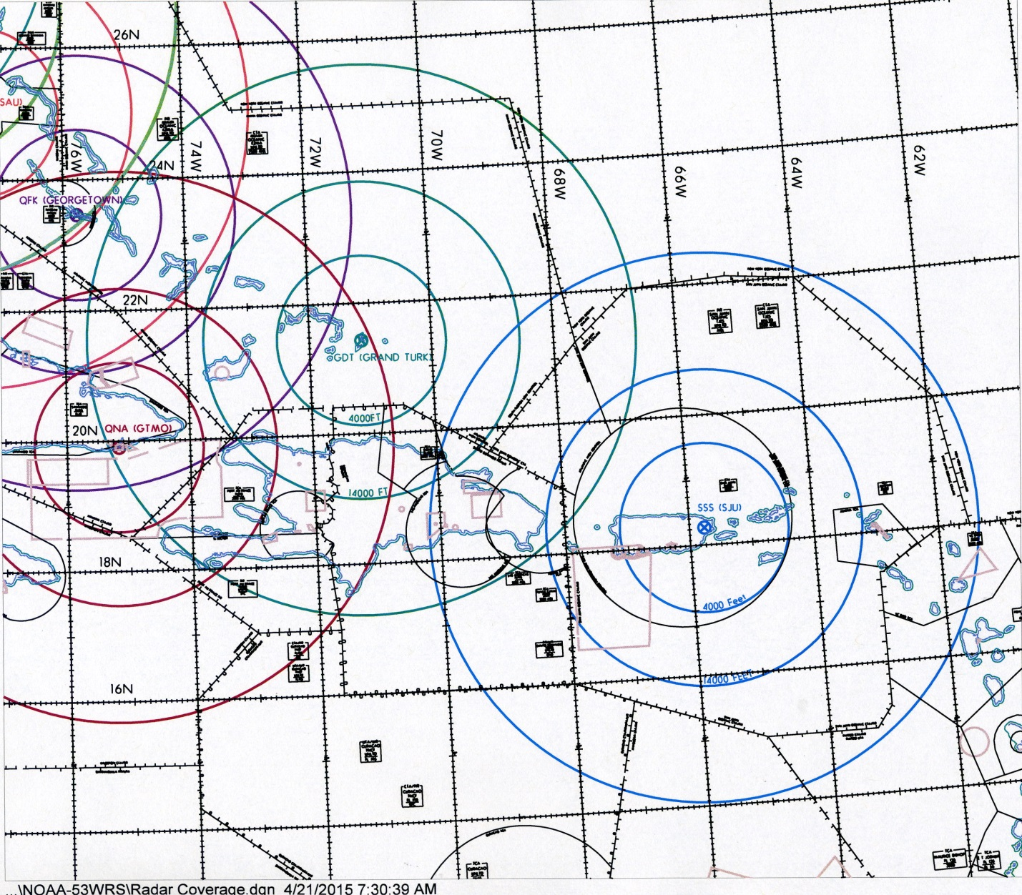
Figure K-10. Radar coverage map – San Juan, PR, Air Route Traffic Control Center. Radar range rings based on line-of-sight shown in color.
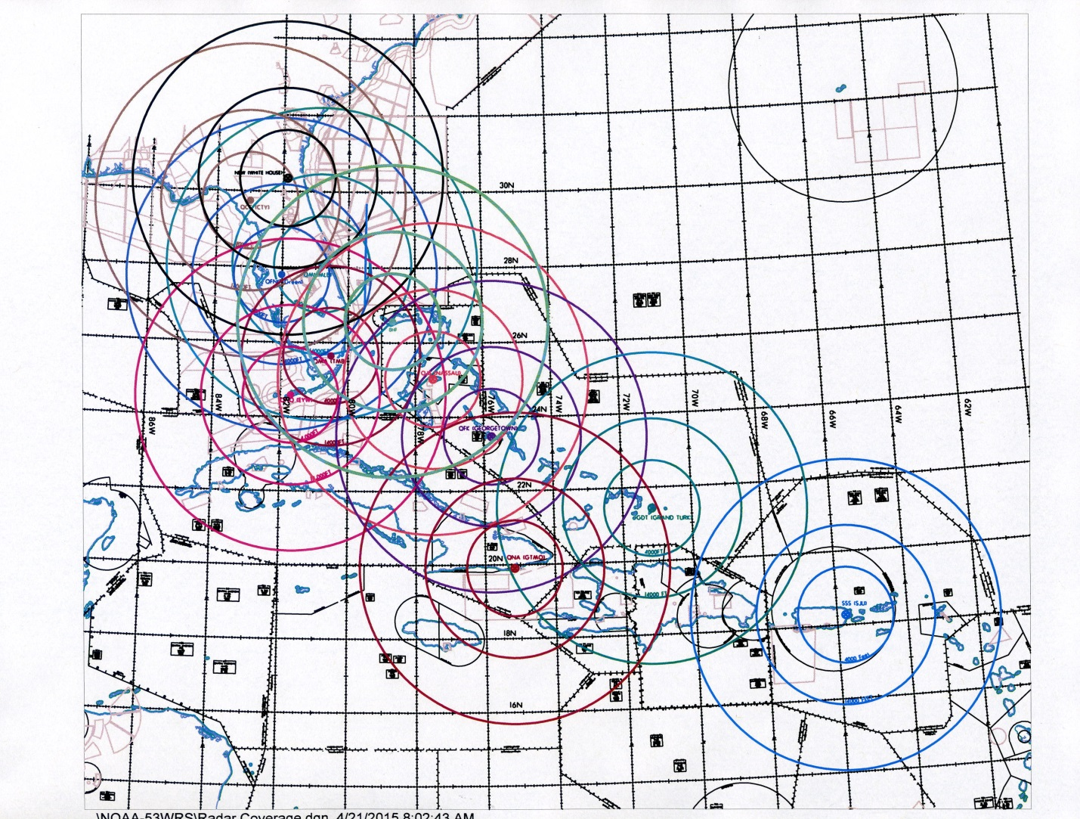
Figure K-11. Radar coverage map – Miami, FL, Air Route Traffic Control Center.
Radar range rings based on line-of-sight shown in color

